Zether demo usage document.

1. add optimism sepoila testnet to your metamask, you can click the Add optimism button in page https://sepolia-optimism.etherscan.io/

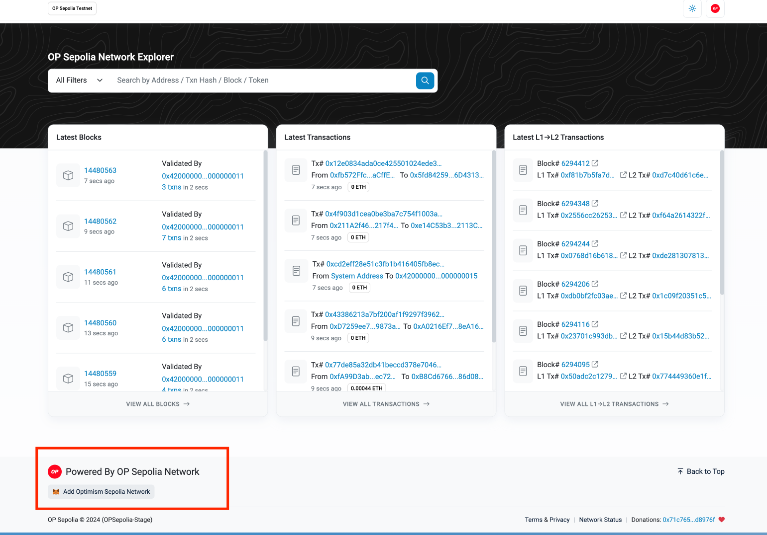

1. add some optimism sepolia testnet eth to your account. If you already have some eth test net sepoilaeth, you can bridge it to op eth with the website <https://testnet.brid.gg/op-sepolia?amount=&originChainId=11155111&token=ETH>

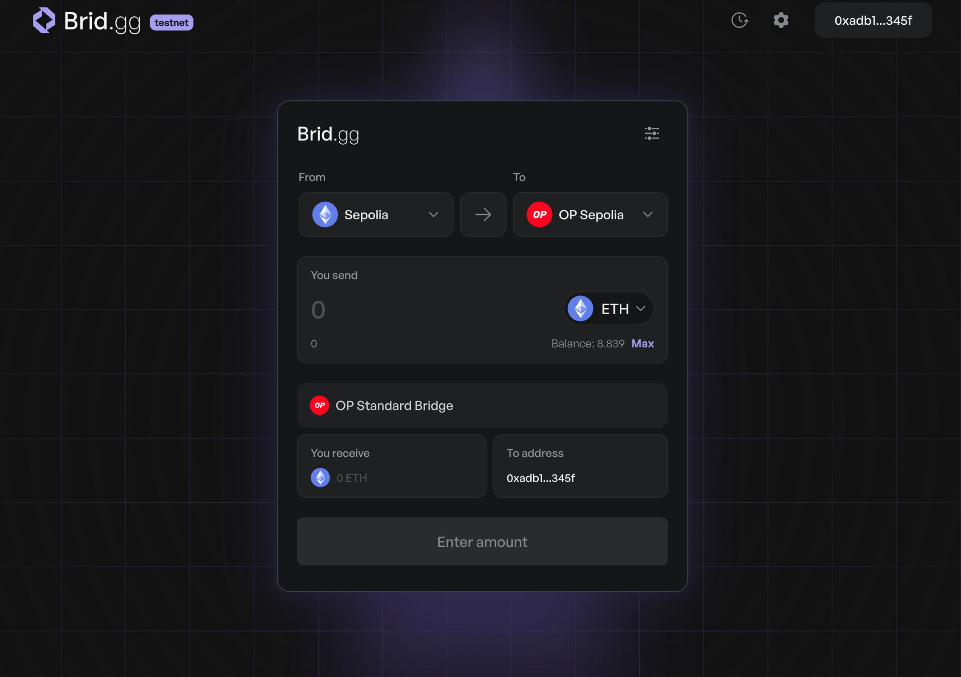

If you don’t have any ethereum sepolia eth, the easiest way to claim some is <https://faucets.chain.link/>, search eth

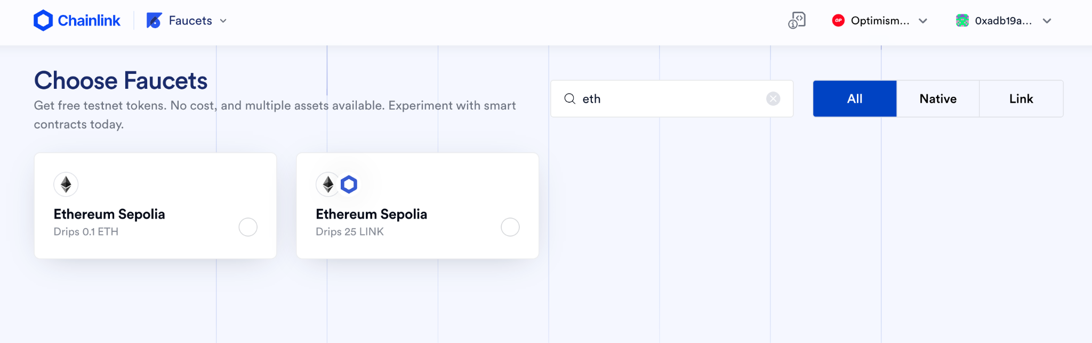

then you can bridge the eth sepolia to op testnet.

1. After you have the op testnet gas coin, you can go to the zether demo page <http://34.140.99.66:8081/>, to connect the wallet to your metamask.



1. it will ask you give permission to the website, you need approval on metamask.

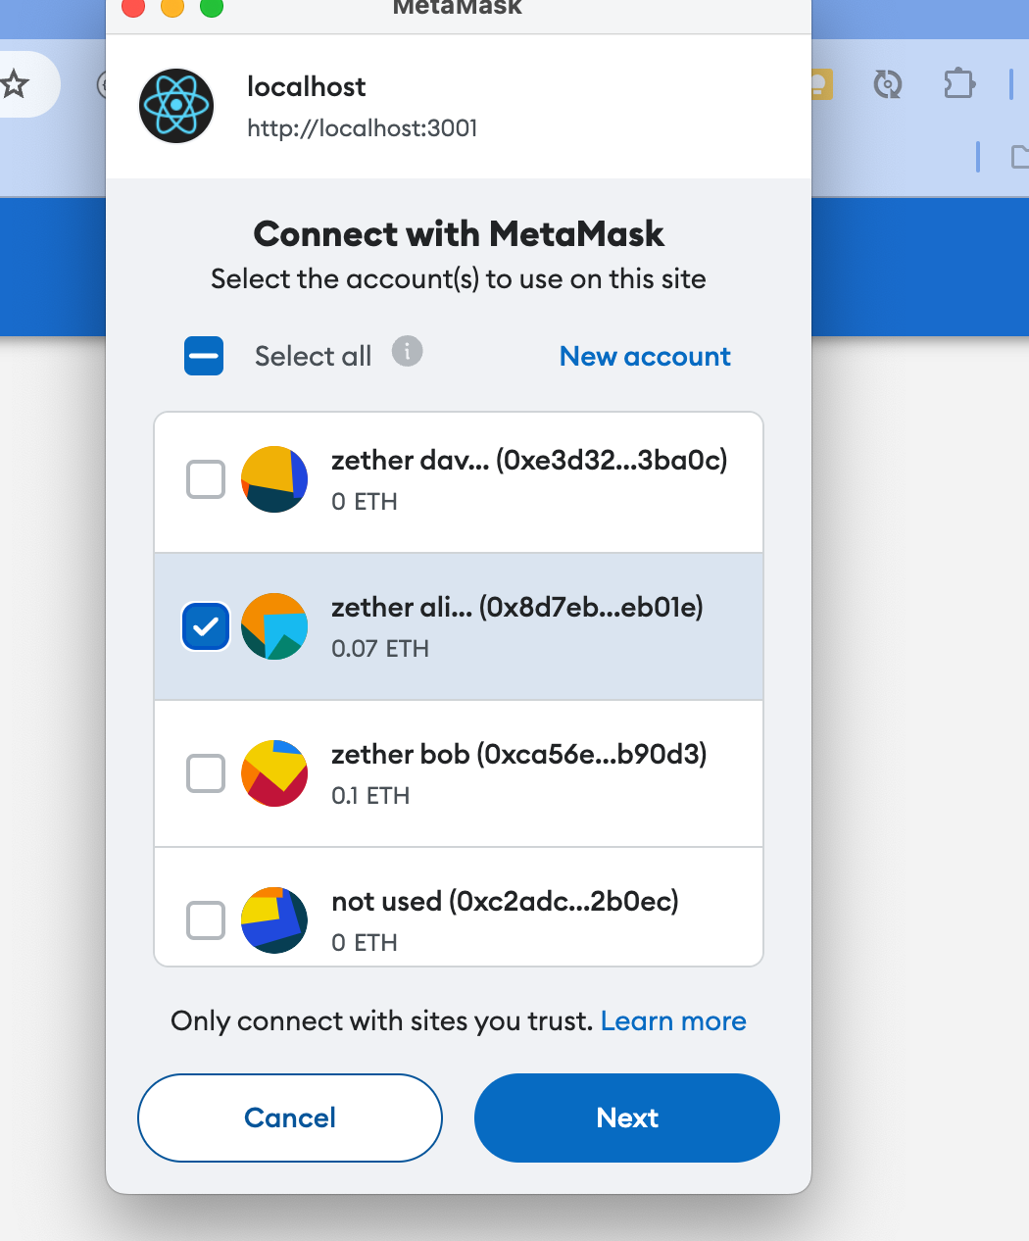

1. Then you are in the page, you will have 0 zth token on the first time, so you can Get More ZTH, and import the zth token address to your metamask

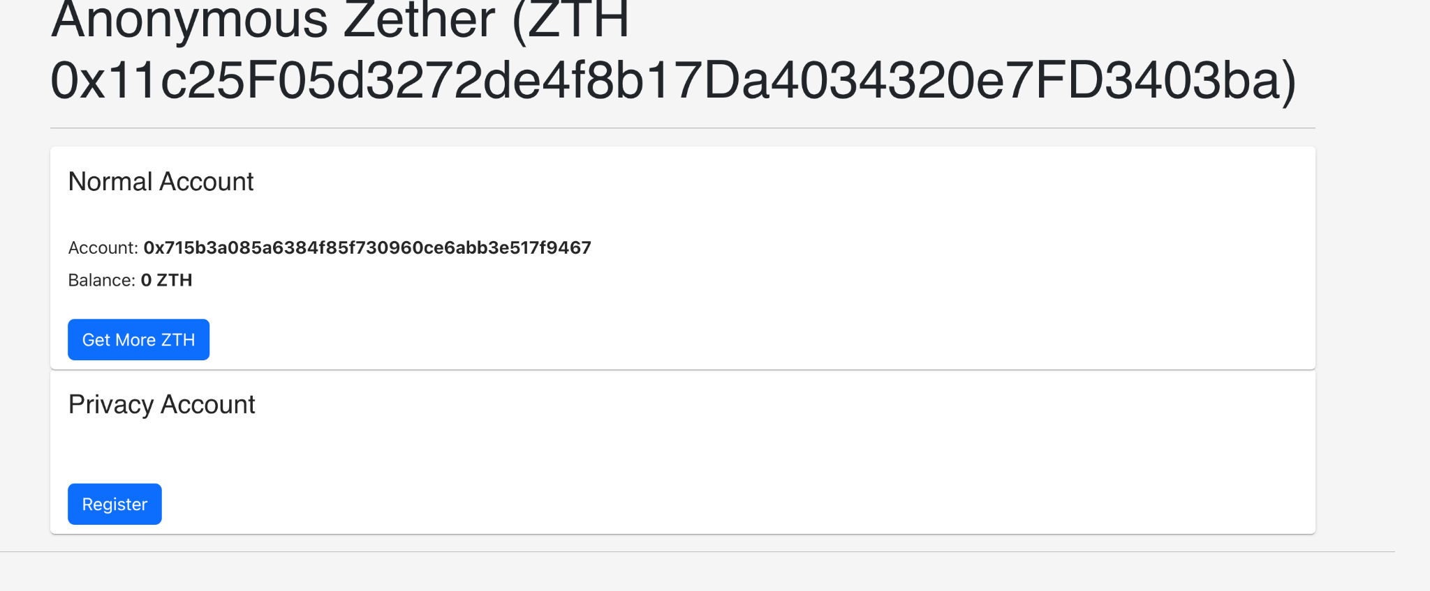

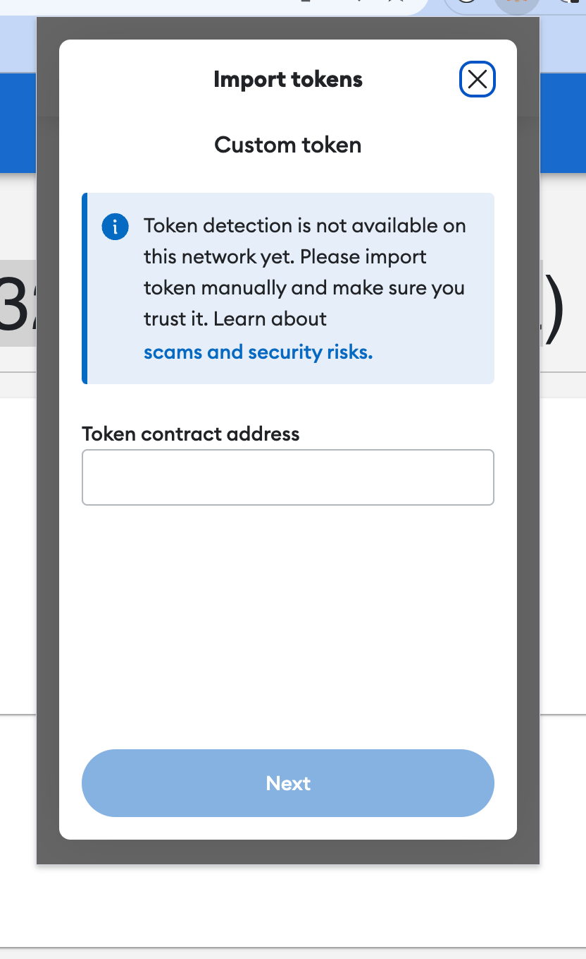

1. Then you need register a privacy account for the zether by click register.Then use metamask to approve and you will ge a privacy account with 0 ZTH.

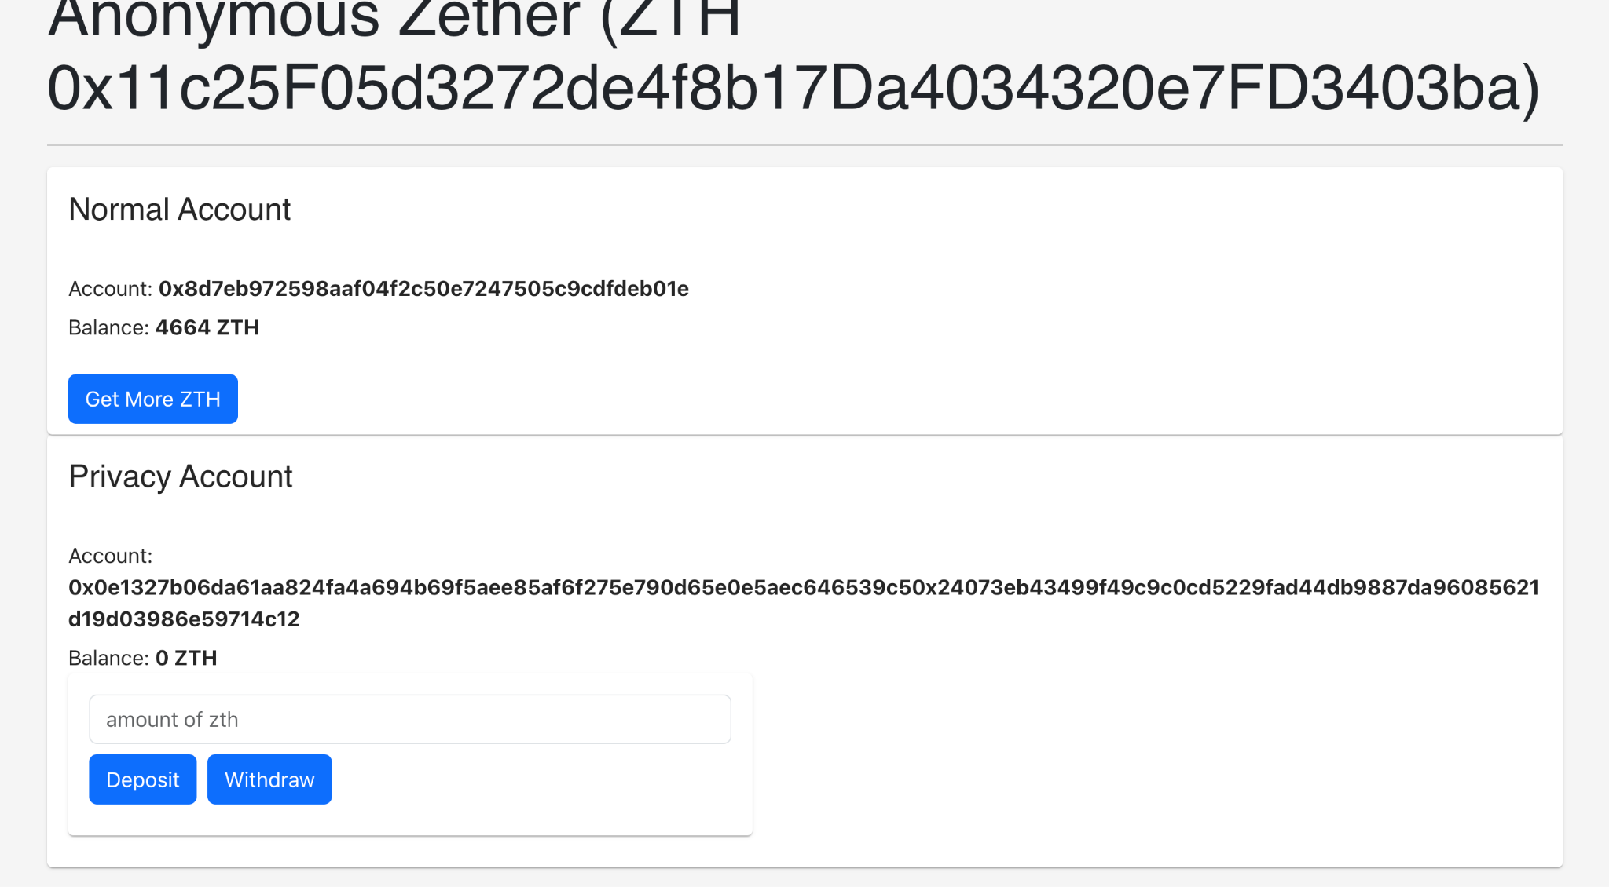

1. you can deposit and withdraw from the privacy account. You move the money from the normal account to a privacy account when you deposit. You move the money from the privacy account to the normal account when you withdraw. The sum number of the two accounts will not change.
2. You can just transfer the ZTH from the normal account to the others with the normal account address just like normal ERC20 token transfer.
3. You can do some privacy transfer with the other's privacy account address and do the privacy transfer.
4. You can explorer normal transaction and privacy transaction with blockchain explorer and see the difference